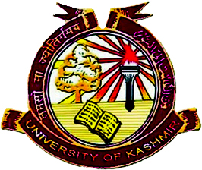**Department of Food Science & Technology**

**University of Kashmir, Hazratbal Srinagar-190 006.**

***(NAAC Accredited Grade – A+)***

**Time Table for Open/General Elective courses**

|  |  |  |  |  |  |
| --- | --- | --- | --- | --- | --- |
| S. No | Title of the course | Name of the Couse Tr. | Class timing/day | Mobile No. | Email |
| 1 | Food Safety (FT18002OE) | Prof F A Masoodi and  Dr. Idrees Ahmed Wani | 2:00 -3:00  PM on Fri & Sat | 7006684149  9596782472 (What App) | [idwani07@gmail.com](mailto:idwani07@gmail.com)  [masoodi_fa@yahoo.co.in](mailto:masoodi_fa@yahoo.co.in) |
| 2 | Lipid Technology (FT 18004GE) | Dr Hilal Ahmad Punoo | 3:05-4:05  PM on Fri & Sat | 7006841011 | [hilalpunoo@gmail.com](mailto:hilalpunoo@gmail.com) |
| 3 | Elementary Milk Products Techn. (FT18003OE) | Dr Adil Gani | 3:05-4:05  PM on Fri & Sat | 7006517458 | [adil.gani@gmail.com](mailto:adil.gani@gmail.com) |

**Head**